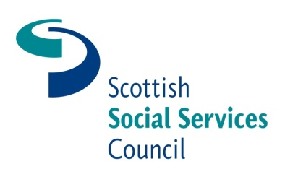

Review of National Occupational Standards in Health and Social Care and Children’s Care Learning and Development

Booking Form

Please complete the form below to secure a place at these events.
Name:
Organisation:
Email address:
Area of Sector: eg early years and child care, residential child care, other children’s services (please specify), care home services for adults, housing support, care at home services, other adult services (please specify)

Which of the following best fits your main role?
Manager
Practitioner
Supervisor
Trainer/Assessor
FE Lecturer
HEI Lecturer
Government Body
Employer
Other (please specify)
If you have any special requirements regarding access, dietary needs, etc, please outline these below:

Please state which event and venue you would like to attend.

Glasgow - 16May at Jury’s Inn |  | http://glasgowhotels.jurysinns.com/DIRECTIONS
Edinburgh – 17 May at Edinburgh Training and Conference Venue |  | http://www.edintrain.com/location.asp
Aberdeen – 7 June at Copthorne Hotel |  | http://www.millenniumhotels.co.uk/copthorneaberdeen/downloads/p_euro_aberdeen.pdf

If you are allocated a place and are then unable to attend please let us know so that we may offer your place to someone else.

Please return this booking form to Vikki McLeish at vikki.mcleish@sssc.uk.com

